**Splint main.c**

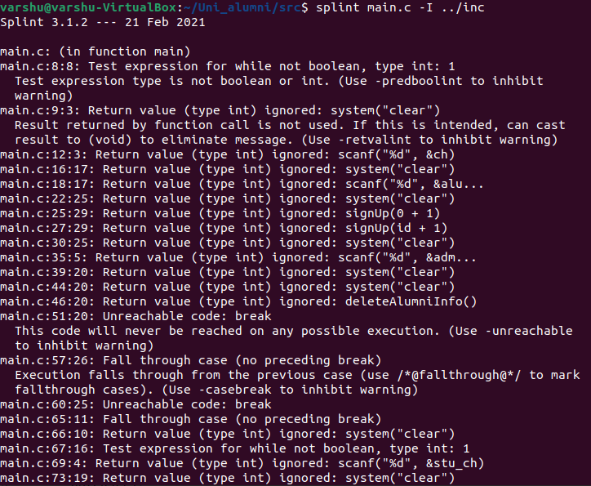

**Splint admin.c**

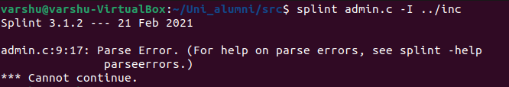

**Splint validations.c**

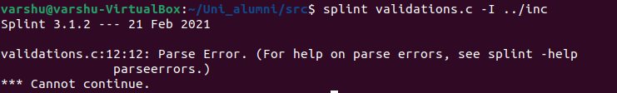

**Splint alumni.c**

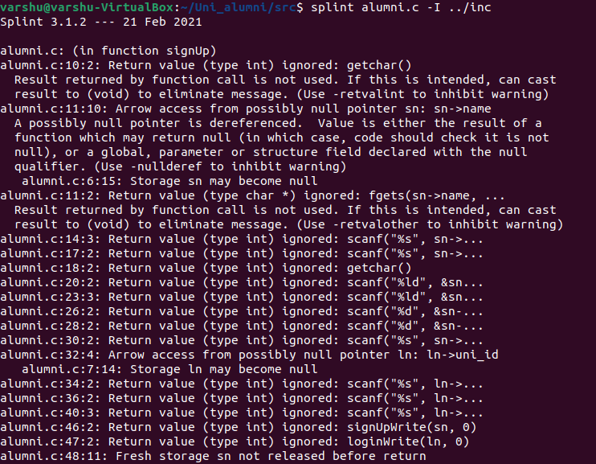

**Splint student.c**

